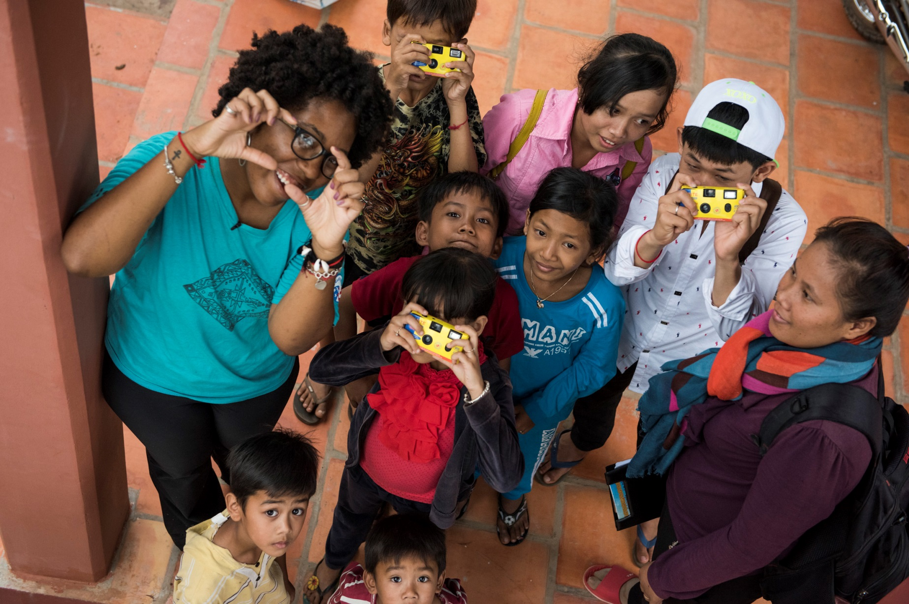



**Peace Corps Lunch & Learn**

**at Chatham University**

***Launch Your International Career!***

# Bring your lunch and join a local returned Peace Corps volunteer to learn more about the opportunity to live, learn, and work with a community overseas. Find out how you can use your skills to make a difference in a developing country!

# Oficial_PC_Logo_09_CMYKFriday, September 18th • 12-1pm

# Mellon Center, Conover Room

# *Register on my.chatham*

# Questions? Contact Lori Frola at [lfrola@peacecorps.gov](mailto:lfrola@peacecorps.gov) or 412.313.1292